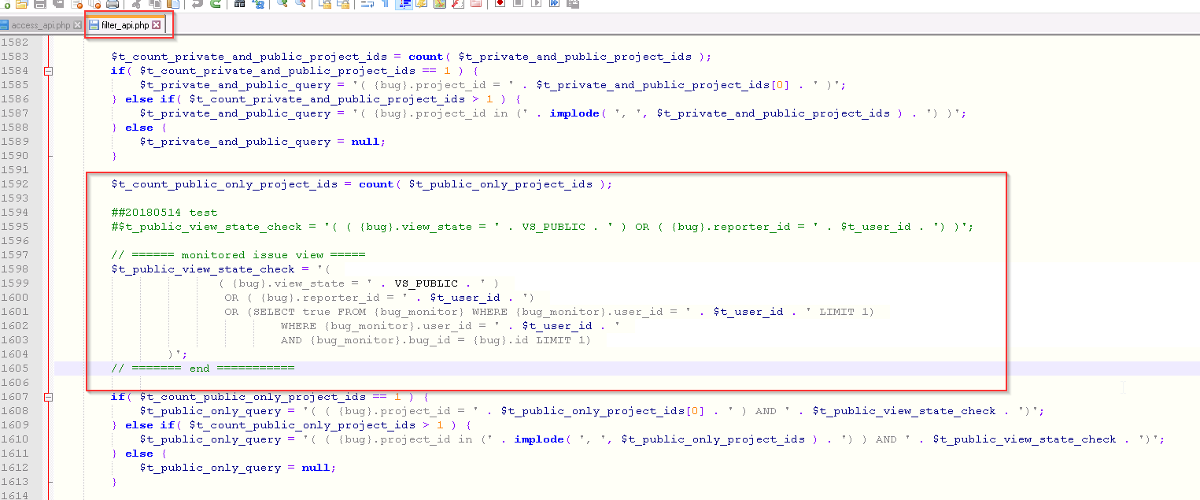

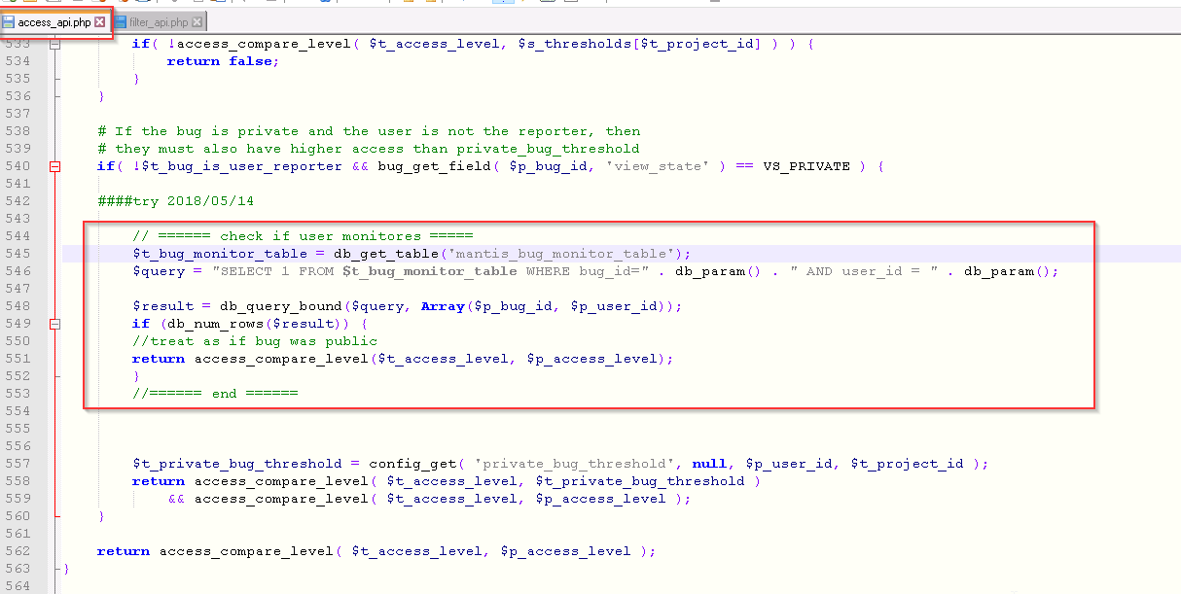

Add the new issue, the view status:Private, and ID:M0503 had add monitoring

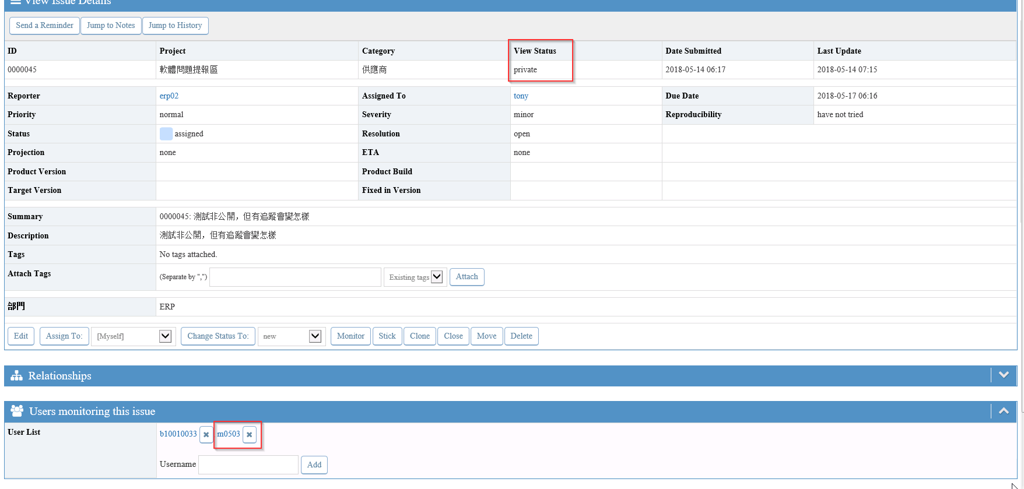

Use ID:m0503 log in, can’t see #0000045 issue

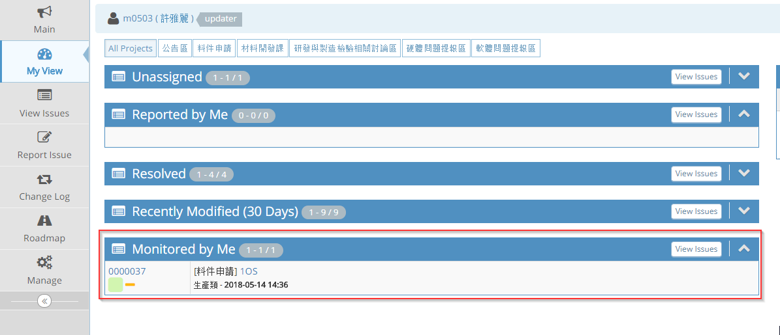

But if use link, ID:m0503 can see this issues.

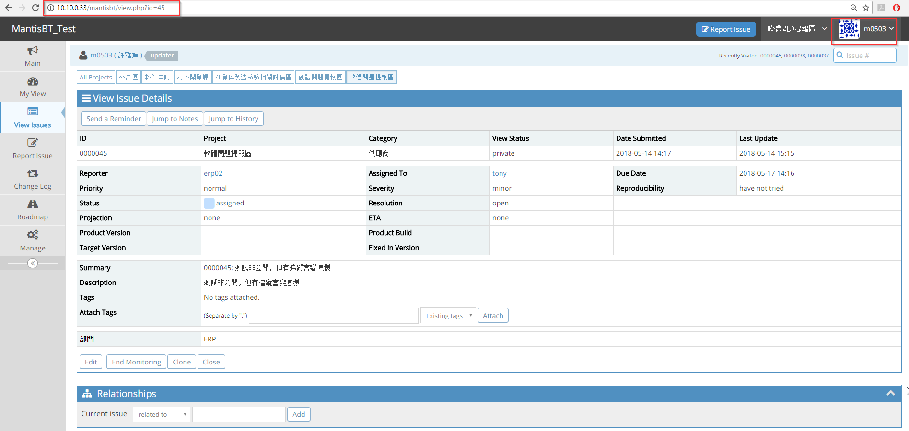

So

at the ‘My View’, I want to see Monitored private issues. How can I set it?

Or am I having a setup error over there?

Thank you.